**Main £8**

The Elms Burger

*Cheese, Tomato, Lettuce, Mayonnaise*

Fish & Chips

*Mushy Peas, Tartar Sauce, Lemon*

Sausage & Chips

*With Peas or Beans*

Pasta

*Tomato Sauce*

**Dessert £4**

Ice Cream

Sticky Toffee Pudding

**Starter £4**

Crudites and Dips

Soup of the Day

K I D S

M E N U

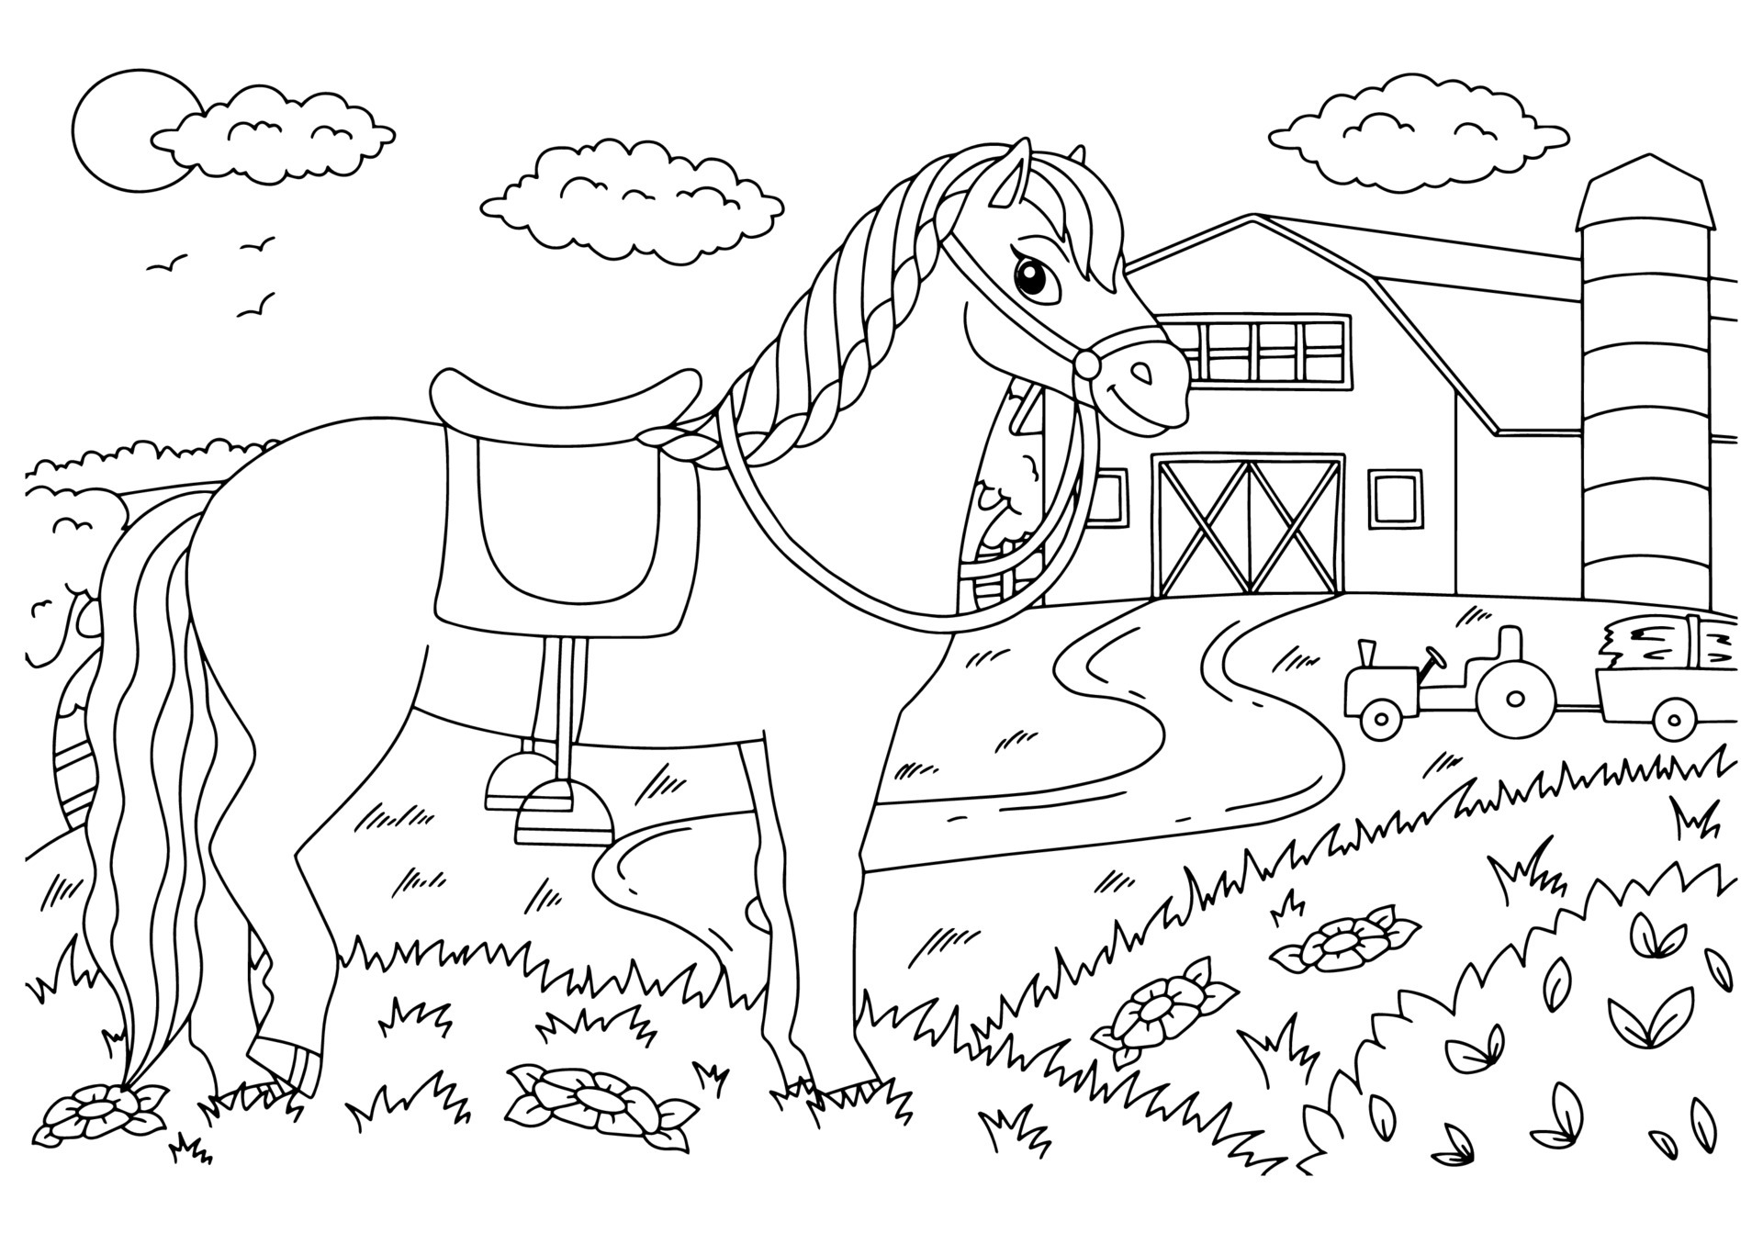

Some of our menu items contain allergens, including; gluten, nuts, milk, eggs, fish, shellfish, soya, celery, mustard, sulphites, sesame and lupin. Whilst every care is taken with your meal, we cannot guarantee a 100% allergen free environment